Year 10 Examinations
Notes

- The K-10 Syllabus, with specific reference to year 10, has been used as a guide in preparing this item bank of questions.

- Questions have been written to cover the content of the year 10 syllabus at 3 different levels. Level A is the most difficult and level C is the least difficult.

- Teachers can use the item bank to make up a Calculator and Non-calculator examination. Students should be given strong hints to include formulae for area and volume, quadratic formula etc in their own set of notes for the examinations.

- The exam is written in the font Century Schoolbook. Teachers should be aware that printers vary and that the formatting of questions may be altered by the capacity of the printer. The formatting of questions will need to be checked.

- A sample cover page is included for the two parts of the examination - a calculator component and a non-calculator component. It is expected that teachers will select 5 -7 questions for each component and that the number of marks will be more than the number of minutes of working time.

- There are no Chance and Data questions in the item bank at this stage.

Year 10 Examinations Questions

Item Bank

Q |  | C | NC | A | B | C
1 | Number Theory, Scientific notation, surds |  | ✓ | 18 | 15
 | Powers | ✓ |  |  |  | 20
2 | Fractions |  | ✓ | 20 | 20 | 20
3 | Percentages |  | ✓ |  |  | 15
 | Percentages | ✓ |  | 10 | 10 | 20
4 | Ratios | ✓ |  |  |  | 20
5 | Direct and Inverse Proportion | ✓ |  | 10 | 10 | 10
6 | Converting between rates | ✓ |  | 10 | 10 | 10
7 | Index Laws |  | ✓ | 20 | 15 | 10
8 | Model linear equations | ✓ |  | 15 | 15 | 10
9 | Linear equations and their graphs |  | ✓ | 20 | 15 | 15
 | Simultaneous linear equations
10 | Solve linear equations |  | ✓ | 20 | 20 | 15
11 | Quadratics, exponentials tables, symbols, graphs |  | ✓ | 15 | 10
 | Sequences | ✓ |  |  |  | 15
12 | Solve quadratic equations by factoring |  | ✓ | 15 | 20
 | Work with quadratics | ✓ |  |  |  | 15
13 | Completing the square and solving equations by quadratic formula or completing the square with reference to graphical solution | ✓ |  | 20 | 10
14 | Graphs of quadratics |  | ✓ | 20 | 15
15 | Graphs of functions |  | ✓ | 15
16 | Length area volume | ✓ |  | 10 | 20 | 20
17 | Circles | ✓ |  | 20 | 20 | 10
18 | Similarity and congruence, transformations | ✓ |  | 20 | 10 | 10
19 | Trig Ratios | ✓ |  |  | 15
20 | Angle relationships | ✓ | ✓ |  |  | 10

Year 10 Semester One

Mathematics Examination
Part One: NO Calculators Allowed

Name ________________________________ Teacher __________________

TIME ALLOWED FOR THIS PAPER
Reading time before commencing : 5 minutes.
Working time for paper : 50 minutes.

MATERIAL REQUIRED /RECOMMENDED FOR THIS PAPER

TO BE PROVIDED BY THE SUPERVISOR
This question paper comprising 5 questions.
Attempt ALL questions.
Total marks for the paper : 70
Answers are to be written on this test booklet in the spaces provided.

TO BE PROVIDED BY THE CANDIDATE
Pens, pencils, eraser,

INSTRUCTIONS TO CANDIDATES
Write all answers in the spaces provided - if working is completed on extra pages, indicate on the original question that your working continues elsewhere.
If extra paper is needed in any section, please ask one of the supervisors.

Show all working clearly, in sufficient detail to allow your answers to be checked readily and for marks to be awarded for reasoning. No marks will be awarded to incorrect answers without supporting reasoning.
Year 10 Semester One

Mathematics Examination
Part Two: Calculators Allowed

Name ________________________________ Teacher __________________

TIME ALLOWED FOR THIS PAPER
Reading time before commencing : 5 minutes.
Working time for paper : 50 minutes.

MATERIAL REQUIRED /RECOMMENDED FOR THIS PAPER

TO BE PROVIDED BY THE SUPERVISOR
This question paper comprising 5 questions.
Attempt ALL questions.
Total marks for the paper : 70
Answers are to be written on this test booklet in the spaces provided.

TO BE PROVIDED BY THE CANDIDATE
Pens, pencils, eraser, ruler
Scientific Calculator
One (1) A4 pages of notes (handwritten, photocopied or typed on both sides) that may be either personally or commercially produced.

INSTRUCTIONS TO CANDIDATES
Write all answers in the spaces provided - if working is completed on extra pages, indicate on the original question that your working continues elsewhere.
If extra paper is needed in any section, please ask one of the supervisors.

Show all working clearly, in sufficient detail to allow your answers to be checked readily and for marks to be awarded for reasoning. No marks will be awarded to incorrect answers without supporting reasoning.
Question 1A [20 marks - NC]

a) Classify each number in the table below by placing a tick in the appropriate places.

 | –5 | 0 | 50% | 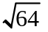 |  |  | 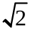
Positive integer
Negative integer
Rational number
Irrational number

[7]

b) (i) The mean radius of the earth is 6 371 000 m. Express this measurement using scientific notation.

(ii) The mean radius of the moon is 1.738 x 10⁶ metres. Write 1.738 x 10⁶ metres as a number without scientific notation.

(iii) The diameter of a single human hair is approximately 0.000 071 m. Express 0.000 071 in scientific notation.

(iv) A nanometre is 10⁻⁹ metres. Express this in decimal form.

[4]

c) Estimate the value of 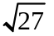. Show how you arrived at your answer.

[3]
d) Simplify the following to an expression that contains radicals of prime numbers.

(i) 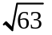 (ii) 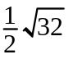

(iii) 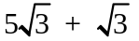 (iv) 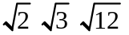

[6]
Question 1B [15 marks - NC]

a) Classify each number in the table below by placing a tick in the appropriate places.

 | –5 | 0 | 50% |  |  | 
Positive integer
Negative integer
Rational number
Irrational number

[7]

b) (i) The mean radius of the earth is 6 371 000 m. Express this measurement using scientific notation.

(ii) The mean radius of the moon is 1.738 x 10⁶ metres. Write 1.738 x 10⁶ metres as a number without scientific notation.

(iii) The diameter of a single human hair is approximately 0.000 071 m. Express 0.000 071 in scientific notation.

(iv) A nanometre is 10⁻⁹ metres. Express this in decimal form.

[8]

Question 1C [20 marks - C]

a) Evaluate the following
(i) 12  100 (ii) 1.45  1000
(iii) 0.15  10 (iv) 527.3  1000
(v) 12 ÷ 10 (vi) 1.45 ÷ 1000
(vii) 0.15 ÷ 100 (viii) 52.3 ÷ 1000
[8]
b) Complete the following table.

1 ÷ 1
1 ÷ 10
1 ÷ 100 | 0.01
1 ÷ 1000
1 ÷ 10000
1 ÷ 100000
1 ÷ 1000000

[3]
b) (i) Use your calculator to evaluate the following powers of 10.

10^{–4}
10^{–3}
10^{–2}
10^{–1} | 0.1
10⁰
10¹
10²
10³
10⁴
[3]
(ii) Comment on any similarities in the two tables.

[2]
c) (i) Hence or otherwise write the decimal number for 1.738 x 10⁴

[2]
(ii) Use your pattern to write 10⁻⁹ metres as a decimal number.

[2]
Question 2A [20 marks - NC]

a) State the value of x when
(i) 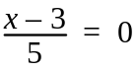 (ii) 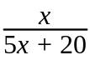 is meaningless

[3]

b) Multiply:

(i)   (ii) 11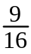

[2]

c) Simplify the following algebraic fractions

(i) 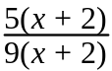 (ii) 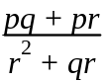

(iii) 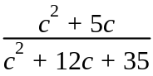 (iv) 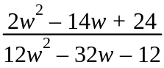

[8]

d) Simplify

(i) 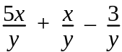 (ii) 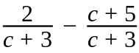

(iii) 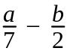 (iv) 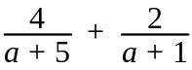

[7]
Question 2B [20 marks - NC]

a) State the value of x when
(i) 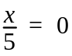 (ii) 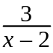 is meaningless

[3]

b) Multiply:

(i)  (ii) 

(iii)   (iv) 11

[6]

c) Simplify the following algebraic fractions
(i) 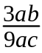 (ii) 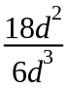

(iii) (iv)

(iv)

[8]

d) Simplify

(i) 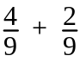 (ii) 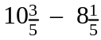

[3]
Question 2C [20 marks - NC]

a) Give three fractions that mean the same as
(i) (ii)

[4]
b) Simplify the following fractions
(i) 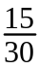 (ii) 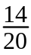
[2]
c) Which is bigger 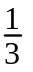 or ? Explain why.

[3]

d) Evaluate these:

(i) of 20 (ii) 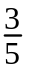 of 20

(iii) of 60 (iii) of 60

[4]
e) What is the result of of ? Explain your answer.

[2]

f) (i) Angela gave half of the chocolate bar to her younger sister and a quarter of it to her mum. What fraction did she have left for herself?

[2]
(ii) Simone lent a quarter of her textas to a friend. She then found out that half of the textas she had left did not work very well. There were 15 that worked. How many textas did she have before she lent any out?

[3]
Question 3A [10 marks - C]

a) An item of clothing is reduced by 15% and then by 10%. Is this the same as a reduction of 25% in total? Explain.

[3]

b) $5 400 is invested for 3 years at an interest rate of 3.4% per annum.

(i) How much interest is earned if the investment is compounded annually?

[3]
(ii) How much interest is earned if the investment is compounded monthly?

[3]
(iii) Is the amount for (ii) greater than or less than (i)? Explain why this is so.

[1]
Question 3B [10 marks - C]

a) An item of clothing is reduced by 15% and then by 10%. Is this the same as a reduction of 25% in total? Explain.

[3]

b) $5 400 is invested for 3 years at an interest rate of 3.4% per annum.

(i) How much interest is earned if the investment is simple interest?

[3]
(ii) How much interest is earned if the investment is compounded yearly?

[3]
(iii) Is the amount for (ii) greater than or less than (i)? Explain why this is so.

[1]
Question 3C [15 marks - NC]

a) Complete the following table, expressing fractions in their simplest form.

fraction | decimal | percentage
 | 0.25
 |  | 10%
 | 0.15
 |  | 100%

[6]
b) Calculate the following percentages

(i) 10% of $3.50 (ii) 20% of $3.50

(iii) 10% of $25 (iv) 5% of $25

[4]

c) Target advertised a storewide discount of 20% off everything. How much would you pay on a top that was marked at $20 before the discount?

[2]

d) Brian got 7 out of 10 for test one and 36 out of 50 for test two. Which test result was better? Show how you arrived at your answer.

[3]

Question 3C [20 marks - C]

a) Liam is working at a surf shop at $12.50 per hour for a 40 hour week.

(i) How much is he paid for 8 hours?

(ii) What is his gross weekly wage?

Liam's deductions are: 21% for income tax and 3% for Health Insurance.
(iii) Calculate the amount he pays in tax each week.

(iv) Calculate the amount he pays in Health Insurance each week?

(v) After deductions, how much of Liam's pay is left to 'take home'?

[8]

b) Jane buys a new car on a hire purchase scheme. The car is advertised for
$18 000. The scheme requires that 20% deposit is paid followed by monthly repayments of $420 for five years.

(i) Calculate the amount of money that is required for the deposit.

(ii) Calculate the amount that is paid in the 5 years.

(iii) How much did the car cost in total?

(iv) What do you notice?

[8]

c) A surf board costs $320. The store is having a sale with everything reduced by 15%. What will the surfboard cost after the discount is applied?

[4]
Question 4C [20 marks - C]

a) Anna is making play dough and mixes different quantities of food colouring to create new colours.
(i) To make orange she mixes 1 drop of red to 2 drops of yellow.
Write this as a ratio of red to yellow.

[1]
- To make dark green she mixes 1 drop of red to 4 drops of blue to 1 drop of yellow. Write this as a ratio of red to blue to yellow.

[1]

- The colour purple is made by mixing red and blue in the ratio 3 : 1. Complete the following table showing different combinations of drops that make purple.

Red | Blue
3 | 1
6
 | 3
15
 | 10
 | 7

[5]
b) Write each of the following as a ratio in simplest form
(i) $10 to $20 (ii) $20 to $15

(iii) 80c to $8 (iv) 2.5 kg to 400g

(v) 80cm to 600mm to 2m

[8]
c) Hot dogs and pies are sold in the ratio 3 : 4 at a local football match.
(i) If 66 hot dogs were sold, how many pies were sold?

[2]

- If a total of 840 hot dogs and pies were sold, how many of these were pies?

[3]
Question 5A [10 marks - C]

a) Complete each statement.

(i) If xy = 25 and x is tripled, then y is _____________

(ii) If y = 8x and x is tripled, then y is ______________

(iii) Over the same distance, doubling the speed causes time to ________.

(iv) If the time of travel is constant then tripling the speed will _______ the distance.

[4]
b) Ryan travelled a distance of 196 km at 80km/h. If he had taken the same amount of time, how far would he have travelled at 95 km/h?

[3]

c) A gear having 36 teeth drives another which has 48 teeth. If the first gear makes 100 revolutions, how many revolutions does the second gear make?

[3]
Question 5B [10 marks - C]

a) Complete each statement:

(i) Over the same distance, doubling the speed causes time to ________.

(ii) If the time of travel is constant then tripling the speed will _______ the distance.

[4]
b) Ryan travelled a distance of 200 km at 80km/h. If he had taken the same amount of time, how far would he have travelled at 100 km/h?

[2]

c) It takes 3 brick layers to finish laying the bricks for a house in 28 days. Assuming the rate that the bricks are laid does not vary,

(i) how many brick layers are required if the job is to be done in 21 days?

(ii) how much longer will it take if only 2 brick layers were able to work?

[4]

Question 5C [10 marks - C]

a) 5kg of juicing carrots cost $3.99.

(i) How much for 1 kg of carrots?

(ii) How much for 10 kg of carrots?

(iii) How much for 3 kg of carrots?

[3]

b) Domonic saves $424 in 16 weeks at a constant rate.

(i) How much did he save by the end of week 9?

(ii) How long did it take him to save $318?

[4]
c) It takes 2 people 12 hours to complete a job. If each person can work at the same rate, how long would it take

(i) 1 person to complete the job?

(ii) 6 people to complete the job?

[3]
Question 6A [10 marks - C]

a) Blake can run 100 m in 12 seconds. Express this rate in

(i) metres per second.

(ii) kilometres per hour.

[4]
b) A car travels at 60 km/h for 5 km and then increases its speed to 80km/h for the next 5 kilometres. What is the average speed for the whole journey?

[3]

c) The drug ibuprofen is found in Nurofen for children at a concentration of
100 mg /5 mL. The dosage for a baby (3-6 months) is 3 mL and the dosage for a child (9-12 yrs of age) is 13 mL. How much of the drug would each category of child have in one dose?

[3]
Question 6B [10 marks - C]

a) Blake can run 100 m in 12 seconds. Express this rate in

(i) metres per second.

(ii) kilometres per hour.

[4]
a) A car travels at 60 km/h for 5 km and then increases its speed to 80km/h for the next 5 kilometres. What is the average speed for the whole journey?

[3]

b) The drug ibuprofen is found in Nurofen for children at a concentration of
100 mg /5 mL. The dosage for a baby (3-6 months) is 3 mL and the dosage for a child (9-12 yrs of age) is 13 mL. How much of the drug would each category of child have in one dose?

[3]
Question 6C [10 marks - C]

a) The speed limit in country areas is 110 km/hour. What is the maximum possible distance that can be travelled in:

(i) 2 hours?

(ii) 30 mins?

[4]
b) Water flows at a rate of 40 L per minute.

(i) How much water is used in a 3 minute shower?

(ii) How long did a shower last if 200L of water was consumed?

[4]

b) The drug ibuprofen is found in Nurofen for children at a concentration of
100 mg/5 mL.
The dosage for a child (7-9 yrs of age) is 10 mL.
How much of the drug is administered in one dose?

[2]

Question 7A [20 marks - NC]

a) Evaluate the following.
(i) 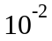 (ii) 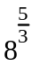 (iii) 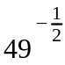

[5]

b) Simplify the following.

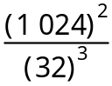

[4]

c) Simplify and express with positive indices.

(i) 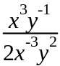 (ii) 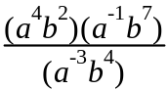

(iii) 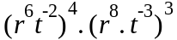 (iv) 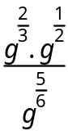

[11]

Question 7B [15 marks - NC]

a) Evaluate the following. Express your answer with positive indices.
(i) 2³ (ii) 2⁻² (iii) 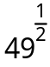

[3]

b) Express 81² as a power of 3.

[3]

c) Simplify and express with positive indices.

(i) 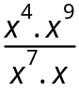 (ii) (2mn)⁶

(iii) (x ⁵)³.(y ⁶)⁴

[6]

d) Simplify 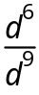 . Express your answer

(i) with positive indices

(ii) without fractions

[3]
Question 7C [10 marks - NC]

a) (i) 2  2  2 can be written as 2³. Evaluate 2³ .

(ii) Evaluate 2⁵.

[2]

b) c  c  c  d can be simplified to c ³d using index notation.
2  c 3  d d simplifies to 6cd ².

Simplify the following using index notation.

(i) f  f  f  f  f  f  f

(ii) 3  f  2  f

(iii) 5  f  f  f  f

(iv) 5  h  2  j  j  j  n  n

[4]
c) Write an expansion for 4a³b².

[2]

d) Consider the following

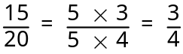

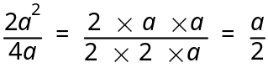

What would 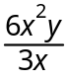 simplify to?

[2]

Question 8A [15 marks - C]

a) The initial temperature of a kiln (oven for baking pottery) is 20°C. Every hour for 8 hours it increases by 60°C.
(i) Construct a table of values that shows the temperature over the 8 hours.

[3]

(ii) Plot an appropriate graph for your table of values.
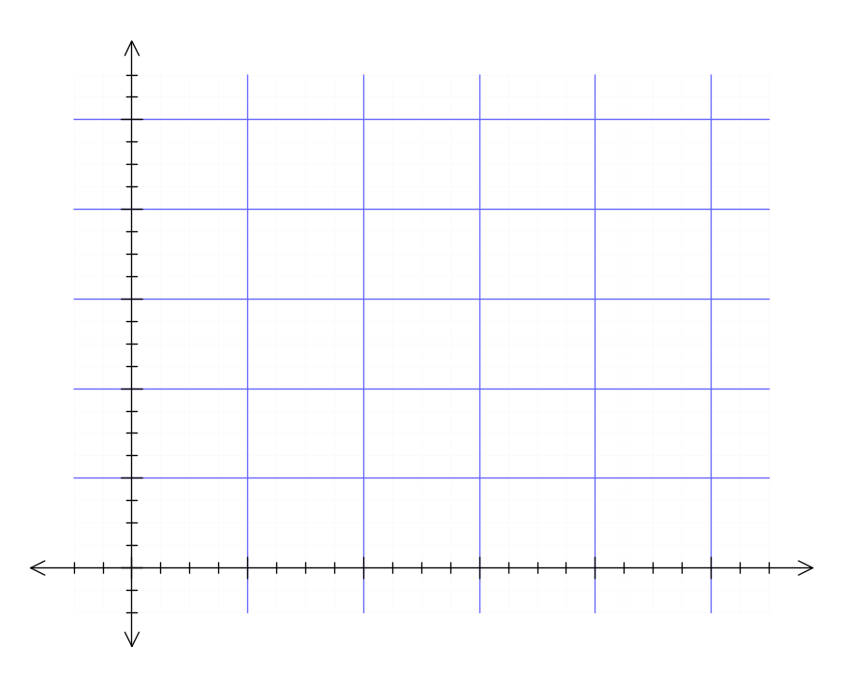 [3]
(iii) Write a rule that connects time (t) to the temperature of the kiln (k).

[2]
(iv) What is the temperature when time is 3 hours and 15 mins? Use your rule.

[3]

(v) Use your equation in (iii) to calculate the time, to the nearest minute, taken for the temperature to reach 256°C.

[4]
Question 8B [15 marks - C]

a) The initial temperature of a kiln (oven for baking pottery) is 20°C. Every hour for 8 hours it increases by 60°C.
(i) Construct a table of values that shows the temperature over the 8 hours.

[3]

(ii) Plot an appropriate graph for your table of values.
[3]
(iii) Write a rule that connects time (t) to the temperature of the kiln (k).

[2]
(iv) What is the temperature when time is 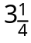 hours? Use your rule.

[3]

(v) Use your equation in (iii) to calculate the time, to the nearest minute, taken for the temperature to reach 256°C.

[4]
Question 8C [10 marks - C]

a) The initial temperature of a kiln (oven for baking pottery) is 20°C. Every hour for 8 hours it increases by 60°C.

(i) Complete the table of values that shows the temperature over the 8 hours.

time (t) | 0 | 1 | 2 | 3 | 4 | 5 | 6 | 7 | 8
temperature (k) | 20°C | 80°C
[3]
(ii) Plot an appropriate graph for your table of values.

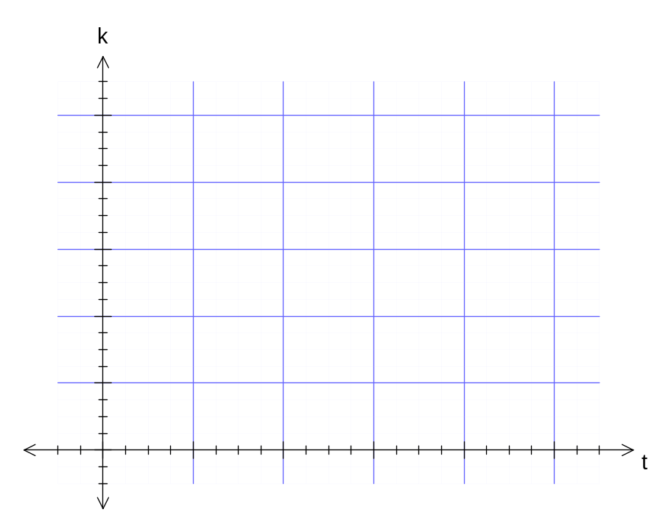
[3]
(iii) Use your graph to estimate the temperature when the time is 3 hours and 30 minutes. Show how you get the answer by indicating appropriately on the graph.

[2]

(iv) Use your graph to estimate the time, to the nearest 30 minutes, taken for the temperature to reach 450°C.

[2]
Question 9A [20 marks - NC]

a) State the gradient and y-intercept of the following:
(i) y = 3 – 4x (ii) 2x – 5y = –10

[4]
b) Write down the equation of a line which is parallel to the y-axis and passes through the point (–3, 2).

[2]

c) Find the equation of the line that passes through (1,5) and has a gradient of .

[3]

d) Find the equation of the line passing through the point (–2, 4) and (3, –2).

[3]

e) Find the equation of a line that is perpendicular to y =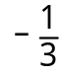 x + 1 and contains the point (–3, 4).

[3]

f) Solve the following pair of simultaneous equations algebraically. Show all of your working.

3x + 4y = –5
x – y = 3

[5]

Question 9B [15 marks -NC]

a) Consider the following graphs of lines.
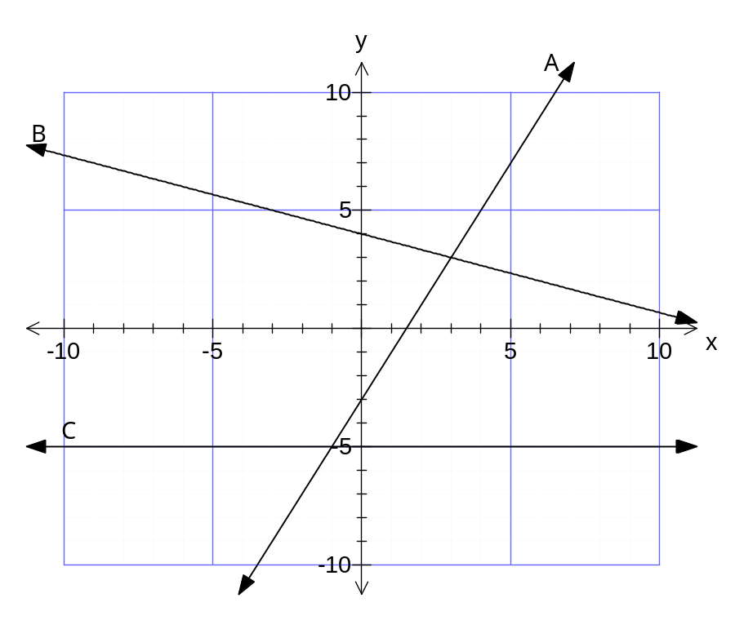
Complete the following table for each line.

line | y-intercept | gradient | equation
A
B
C

[6]
b) State the gradient and y-intercept of the following:

(i) y = 3 – 4x (ii) 2x – 5y = –10

[4]

f) Solve the following pair of simultaneous equations algebraically. Show all of your working.

3x + 4y = –5
x – y = 3

[5]
Question 9C [15 marks -NC]

1. Consider the following diagrams.

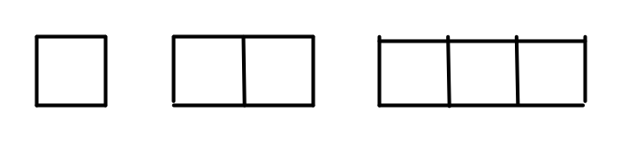
(i) Draw the next two diagrams in the pattern.
[2]
(ii) Complete the following table

Diagram number (x) | 1 | 2 | 3 | 4 | 5 | 10
Number of lines (y) | 4 | 7 |  |  |  |  | 46

[6]
(iii) Describe how to get the number of lines from the diagram number.

[2]

(iv) Write your rule using symbols.

[2]
(v) Draw an appropriate line graph on the axis below.
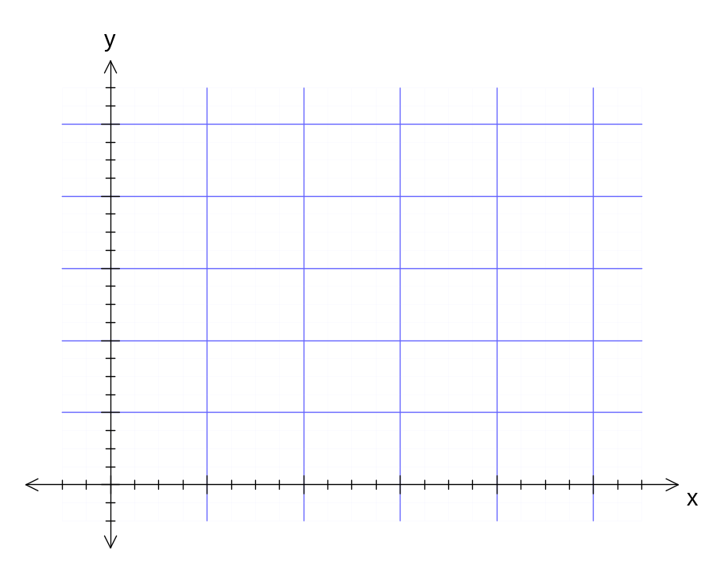
[3]
Question 10A [20 marks - NC]

a) Solve the following equations

(i) 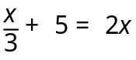

(ii) 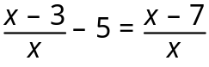

(iii) 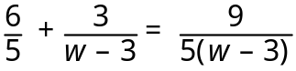

[9]

b) The formula that can be used to find surface area A cm² of a solid cylinder with radius r cm and height h cm is A = 2r(r + h)

(i) Find A when r = 8 and h = 12

[1]

(ii) Transpose the equation to make h the subject. ie h =

[3]

(iii) Hence or otherwise, find h when A = 240 and r = 10.

[2]

c) Three boys earned $60 together. William earned $2 less than Harry and Jack earned twice as much as William. Find out how much each boy earned.

[5]
Question 10B [20 marks - NC]

a) Solve the following equations
(i) 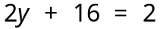 (ii) 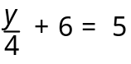

(iii) 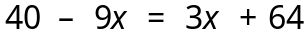 (iv) 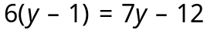

[10]

b) The formula that can be used to find the volume, V cm³ of a rectangular prism is V = lwh.

(i) Find V when l = 8, w = 6, h = 2.

[2]

(ii) Transpose the equation to make w the subject. (ie w =)

[2]

(iii) Hence or otherwise, find w when V = 240, l = 3 and h = 10.

[2]
c) Four times a number increased by 45 equals seven times the number.
(i) Let the number be n. Write an equation that matches the situation.

(ii) Solve your equation to find the number.

[4]
Question 10C [15 marks- NC]

a) Solve the following equations

(i) 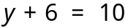 (ii) 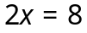

(iii) 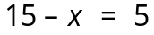 (iv) 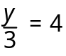

(v) 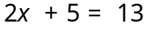 (vi) 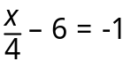

[8]

b) The formula that can be used to find the volume, V cm³ of a rectangular prism is
V = lwh.

Find V when

(i) l = 8, w = 6, h = 2.

(ii) l = 10, w = 10, h = 10.
[4]

c) A number is multiplied by 4 and then increased by 8. The result equals 20.

(i) Let the number be n. Write an equation that matches the situation.

(ii) What is the number?

[3]

Question 11A [15 marks - NC]

a) State the type of relationship (linear, quadratic, exponential or neither) and a rule that shows the relationship between x and y, for each table of values.
(i)
x | 0 | 1 | 2 | 3 | 4 | 5
y | 3 | 4 | 7 | 12 | 19 | 28

(ii)
x | 0 | 1 | 2 | 3 | 4 | 5
y | –1 | 1 | 3 | 5 | 7 | 9

(iii)
x | 1 | 2 | 3 | 4 | 5 | 6
y | 6 | 3 | 2 | 1.5 | 1.2 | 1

(iv)
x | 0 | 1 | 2 | 3 | 4 | 5
y | 25 | 22 | 19 | 16 | 13 | 10

(v)
x | 0 | 1 | 2 | 3 | 4 | 5
y | 0 | 3 | 12 | 27 | 48 | 75

(vi)
x | 0 | 1 | 2 | 3 | 4 | 5
y | 1 | 3 | 9 | 27 | 81 | 243

(vii)
x | –1 | 0 | 1 | 2 | 3 | 4
y | 0.4 | 2 | 10 | 50 | 250 | 1250

Question 11B [10 marks - NC]

a) State the type of relationship (linear, quadratic or neither) for each of the tables of values below.
State the rule that shows the relationship between x and y for those that you identify to be linear or quadratic.
(i)
x | 0 | 1 | 2 | 3 | 4 | 5
y | 3 | 4 | 7 | 12 | 19 | 28

(ii)
x | 0 | 1 | 2 | 3 | 4 | 5
y | –1 | 1 | 3 | 5 | 7 | 9

(iii)
x | 1 | 2 | 3 | 4 | 5 | 6
y | 6 | 3 | 2 | 1.5 | 1.2 | 1

(iv)
x | 0 | 1 | 2 | 3 | 4 | 5
y | 25 | 22 | 19 | 16 | 13 | 10

(v)
x | 0 | 1 | 2 | 3 | 4 | 5
y | 0 | 3 | 12 | 27 | 48 | 75

(vi)
x | 0 | 1 | 2 | 3 | 4 | 5
y | 1 | 3 | 9 | 27 | 81 | 243

Question 11C [15 marks- C]

a) Find the next 3 numbers for each number sequence below. For each sequence describe how you get your numbers from the previous number(s).

(i) 2, 4, 6, 8, 10, ____, _____, _____
Description

(ii) 2, 4, 8, 16, 32, ____, _____, _____
Description

(iii) 1, 4, 9, 16, 25, ____, _____, _____
Description

(iv) 50, 42, 34, 26, 18, ____, _____, _____
Description

(v) 1, 1, 2, 3, 5, 8, 13, ____, _____, _____
Description

Question 12A [15 marks- NC]

1. a) Solve the following by factoring:
(i) a² – 49 = 0 (ii) 3r² – 21r = 0

[6]

b) The length of a rectangular lot is 3 metres more than its width.
(i) Let the width be w. Draw a diagram and label the length and width in terms of w.

(ii) Find the length and width of the rectangular lot if the area is 40m².

[5]

c) Solve by equating to 0 and factoring.

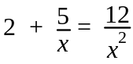

[4]

Question 12B [20 marks - NC]

a) Solve these equations.

(i) (x – 3) (2x + 1) = 0 (ii) x² + 9x + 20 = 0

(iii) a² – 49 = 0 (iv) 3r² – 21r = 0

(v) x² – x = 6

[15]

b) The length of a rectangular lot is 3 metres more than its width.

(i) Let the width be w. Draw a diagram and label the length and width in terms of w.

(ii) Find the length and width of the rectangular lot if the area is 40m².

[5]

Question 12C [15 marks - C]

a) Find the value of the expression x² – 6x + 5 when x is 0, 1, 2, 3, 4, 5 and 6 to complete the following table.

For example, when x = 2 ,
x² – 6x + 5
= 2² – 62+5
= –3

x | x² – 6x + 5
0
1
2 | –3
3
4
5
6
[6]

b) Use your table to work out the values of x that make this equation true.
x² – 6x + 5 = 0

[2]

c) The length of a rectangular lot is 3 metres more than its width.

(i) Find the area of various rectangles given this condition by completing the table below.

width | length  (width + 3) | area
1 m
2 m | 5 m (ie 2 + 3) | 10 m²
3 m
4 m
5 m
6 m

(ii) State the length and width of the rectangular region if an area of 40 m² is required?

[7]
Question 13A [20 marks - C]
a) Complete the square for
(i) x² + 2x – 10 (ii) –x² – 2x + 10

[6]
b) Solve for x, to 2 decimal places, by using the quadratic formula or completing the square.
(i) x² + 2x – 10 = 0 (ii) 2x² + 4x = –5

[6]

c) Hence, or otherwise, make a sketch of the curves,
y = x² + 2x – 10 and y = –x² – 2x + 10 ,
on the following axis. Indicate clearly the turning points, y intercepts and lines of symmetry.
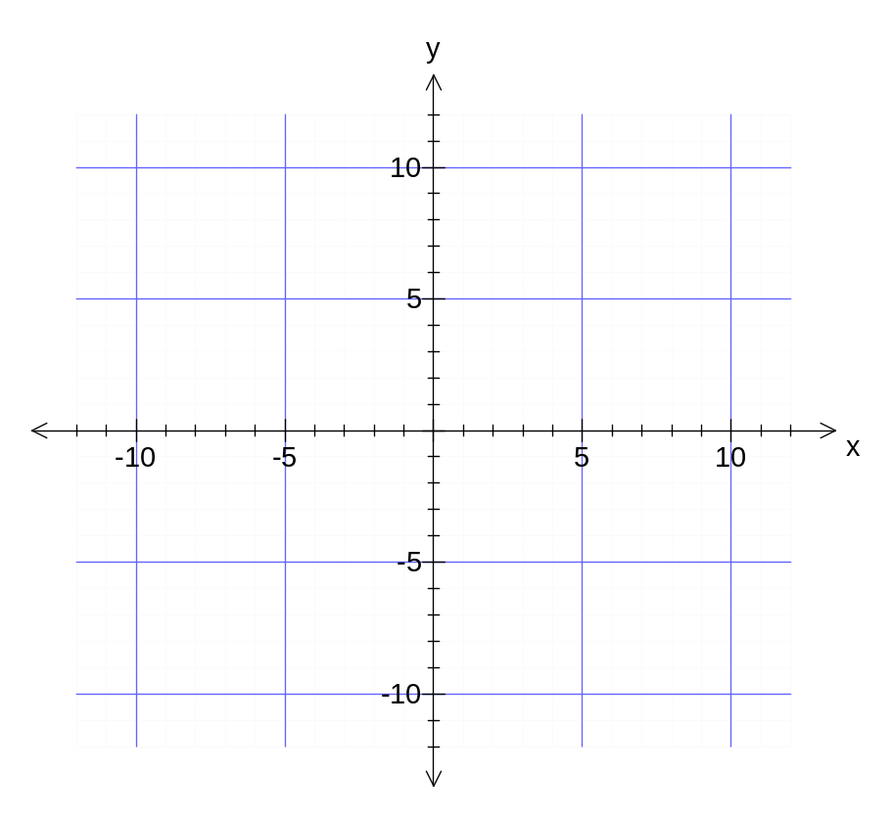
[6]
d) How are your answer(s) in part b) significant to this part c)?

[2]

Question 13B [10 marks - C]

a) Complete the square for x² + 2x – 10

[3]

b) Solve for x, to 2 decimal places, by using the quadratic formula or completing the square.
x² + 2x – 10 = 0

[3]

c) Hence, or otherwise, make a sketch of the curve, y =x² + 2x – 10, on the following axis. Indicate clearly the turning point, y intercept and line of symmetry.
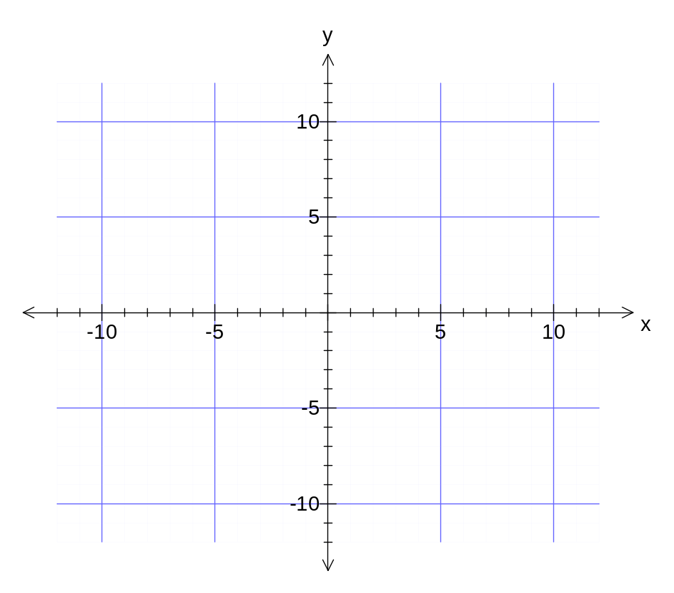
[3]
d) How are your answer(s) in part b) significant to this part c)?

[1]
Question 14A [20 marks - NC]

1. Complete the following table by matching each graph (A, B, C, D, E, F) with an equation below. Some graphs may not be matched.
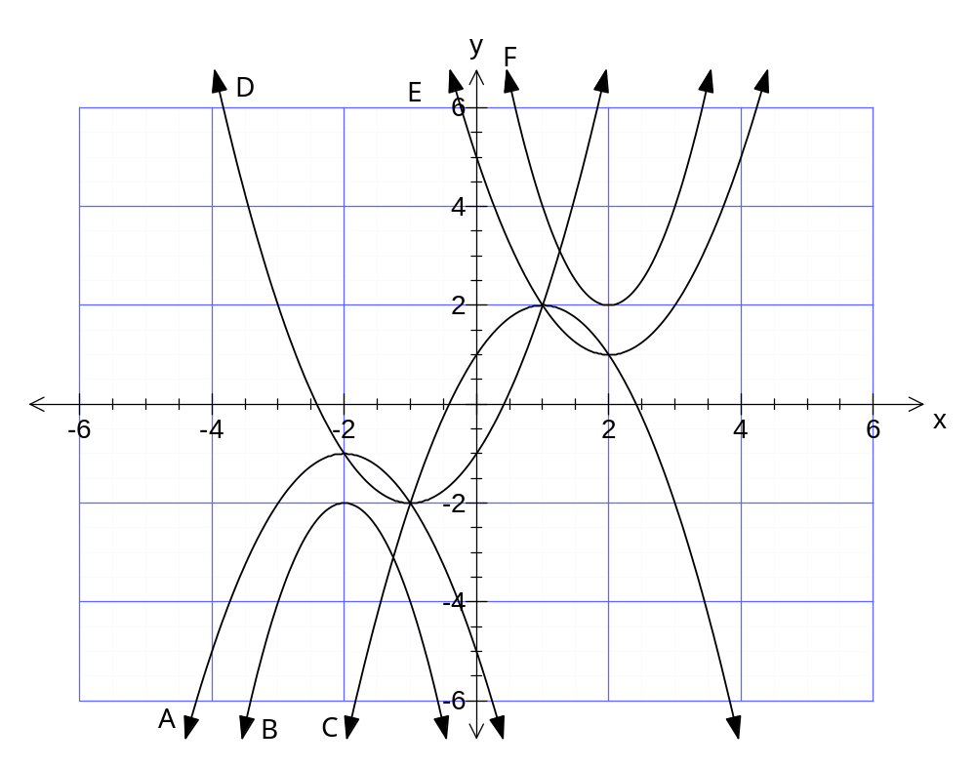

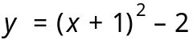 | 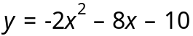 | 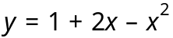 | 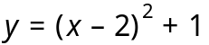

[8]
b) The graph of y = x² is translated 3 units to the right and 4 units down. What is the equation of the new parabola?

[3]

c) (i) The graph of y = 2x² is reflected about the x- axis, then translated 1 unit left and 2 units up. What is the equation of the new parabola?

[4]
(ii) What is the turning point, y intercept and equation of line of symmetry of the new curve?

[5]
Question 14B [15 marks - NC]

1. Complete the following table by matching each graph (A, B, C, D, E, F) with an equation below.
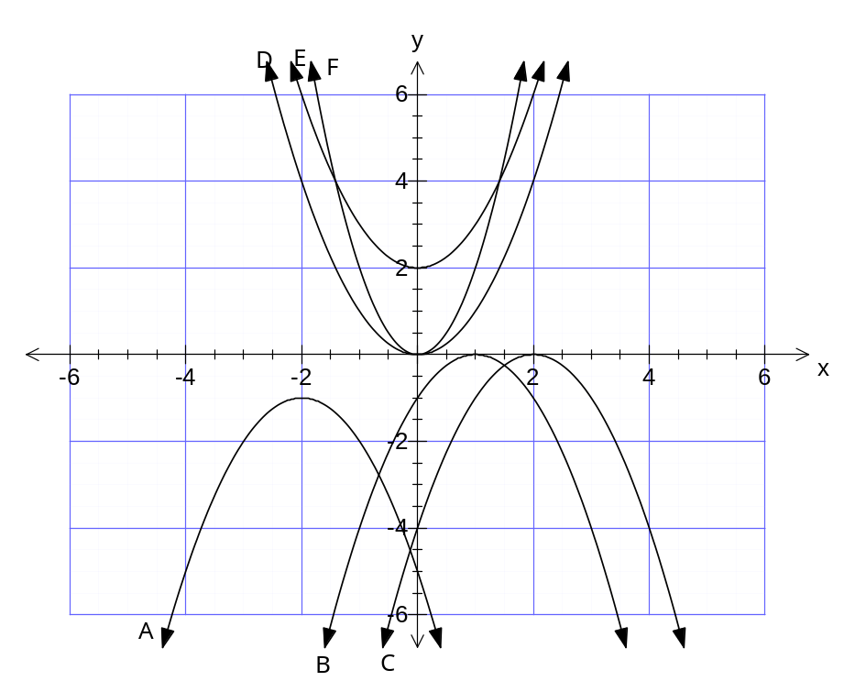
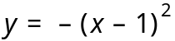
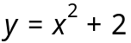
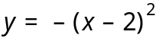
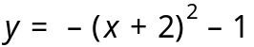
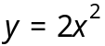
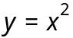
[6]
b) (i) The graph of y = x² is translated 3 units to the right. What is the equation of the new parabola?
[2]

(ii) State the turning point, equation of line of symmetry and y-intercept of the new parabola.

[4]

c) The graph of y = 2x² is reflected about the x- axis, then translated 1 unit left and 2 units up. [3]

Question 15A [15 marks - NC]

a) (i) Next to each function below, state whether the relationship between x and y is linear (L), quadratic (Q), exponential (E) or reciprocal (R). All other variable represent constants.

y = a(x – b)² + c ___________ y = ax +b ___________
y = ab^{x} ___________ xy = b ___________
y = ax²+bx +c ___________ y = a(x + b)(x + c) ___________
[6]
(ii) State whether the relationship between x and y is linear (L), quadratic (Q), exponential (E) or reciprocal (R) by placing the appropriate letter next to the graph.
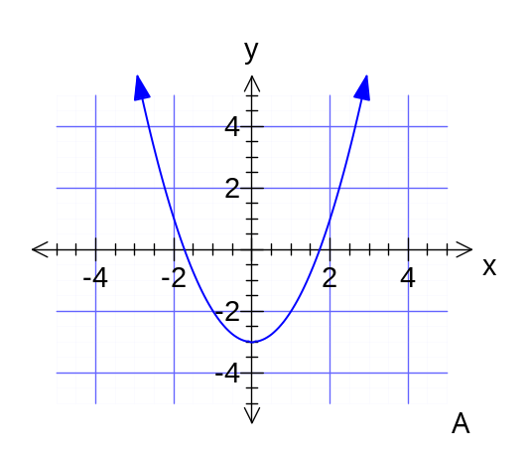 | 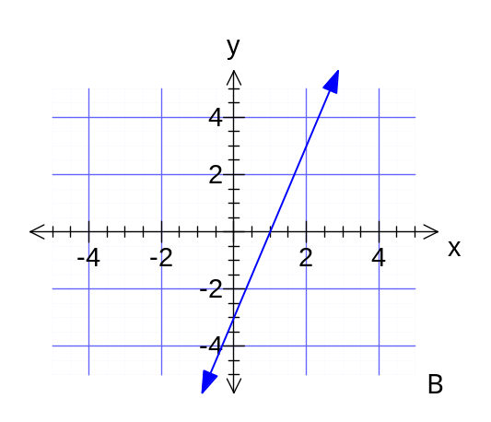
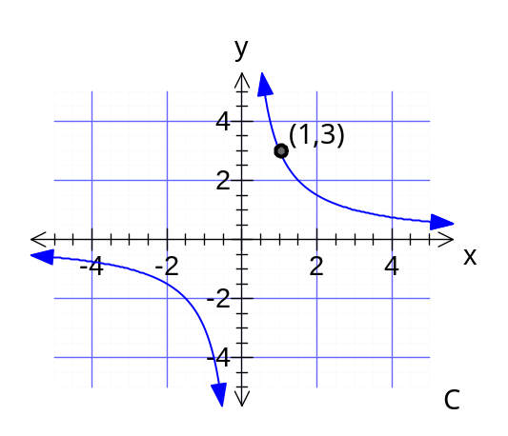 | 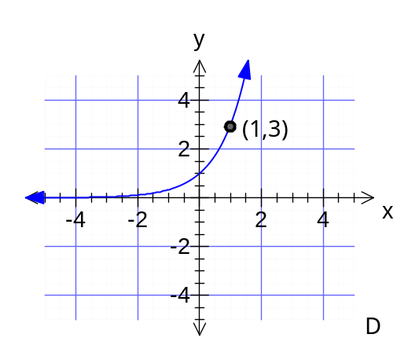

[4]
(iii) Give the function for each graph.

A ________________
B ________________
C ________________
D ________________

Question 16A [10 marks- C]

Find the surface area and volume of this wooden spike that consists of a square pyramid on top of a square prism. The square on the base of the prism is 2 cm in width and the height of the square prism is 18 cm. The total height of the 3D shape is 22 cm.

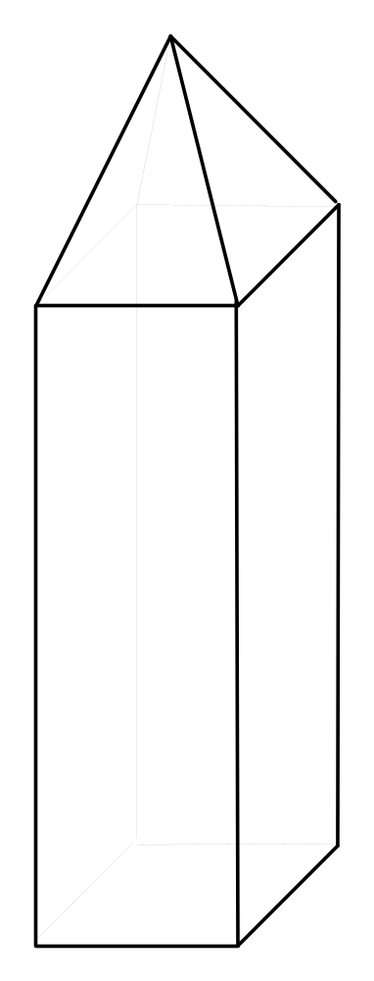
Question 16B [20 marks - C]

a) (i) Sketch a diagram for the net of the following triangular prism. Indicate all of the lengths of each polygon that make up the net.

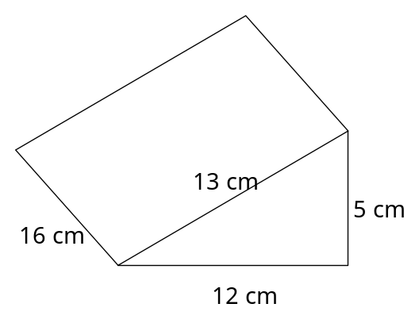
[3]
(ii) Calculate the surface area of the prism.

[4]
(iii) Calculate the volume of the prism.

[3]

b) A square pyramid has a square base with sides of 4.5 cm and a perpendicular height of 6.2 cm. What is its volume?

[3]

c) (i) How many square centimetres in a square metre?

[1]

(ii) How many cubic centimetres in a cubic metre?

[1]
d) (i) How many 2 cm cubes in a rectangular prism with dimensions
8 cm  6 cm  10 cm?

[1]

(ii) How many 2 cm cubes will fill the prism if all of the dimensions are doubled?

[2]
(iii) How many 2 cm cubes will fill the prism if only the 8 cm and 6 cm side were doubled?

[2]
Question 16C [20 marks - C]

a) Calculate the perimeter and area of the following shapes.
(i) (ii)
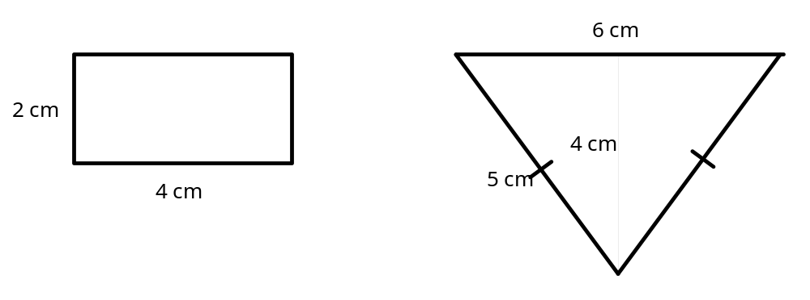

[6]

b) (i) Give the dimensions (length and width) of three rectangles that have a perimeter of 16 cm.

[2]
(ii) Give the dimensions of three rectangles that have an area of 24 cm².

[2]

c) Find the volume of each of the shapes below by counting the number of cubic units in each
(i) (ii)
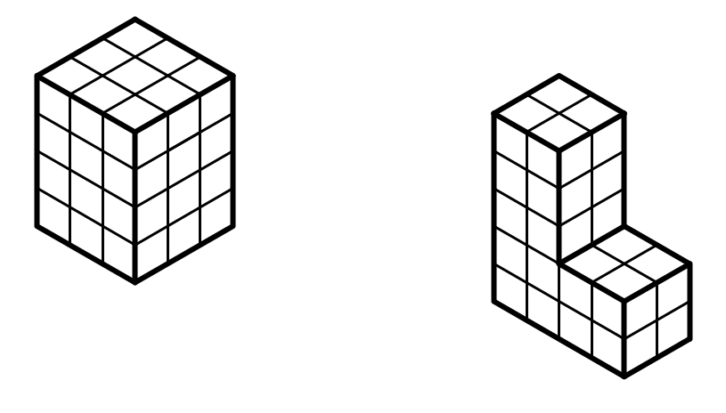
[4]
d) On the isometric grid below, draw three different shapes that would have a volume of 8 cm³.



[6]

Question 17A [20 marks - C]

a) For any circle, state a formula which shows the relationship between
(i) the circumference (C) and an arc (l) that subtends an angle of 45°.

(ii) the semi-circumference (S) and the radius (r).

(iii) an arc (l) that subtends an angle of 120° at the centre of the circle and the diameter of the circle (d).

[4]
b) Calculate the perimeter and area of the following shape.
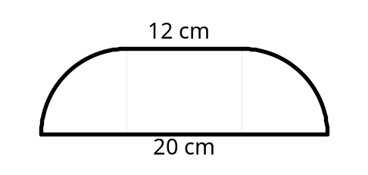

[6]

c) Find the volume and surface area of the following solid.

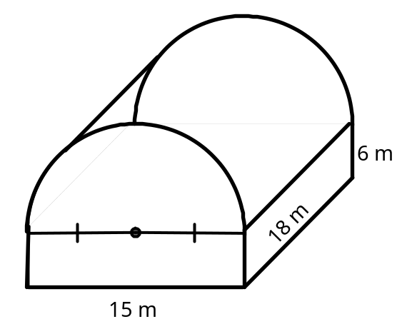

[10]

Question 17B [20 marks - C]
a) Find the perimeter and area of the following shapes.
(i) (ii)
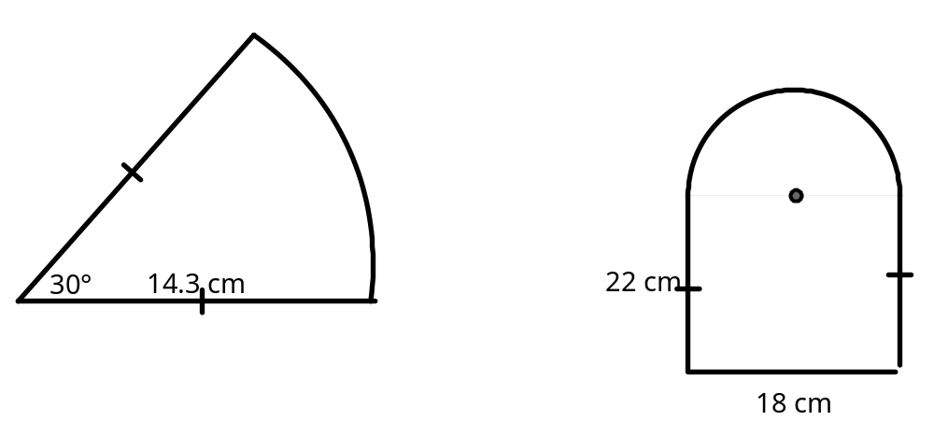

[9]

b) Find the volume and surface area of a cylinder that has a radius of 7.4 cm and a height of 10.5 cm

[8]

c) What is the volume of a cone with base radius of 3.4 cm and perpendicular height of 9 cm.

[3]

Question 17C [10 marks]

a) Measure with a string the circumference and diameter of each of the following circles.
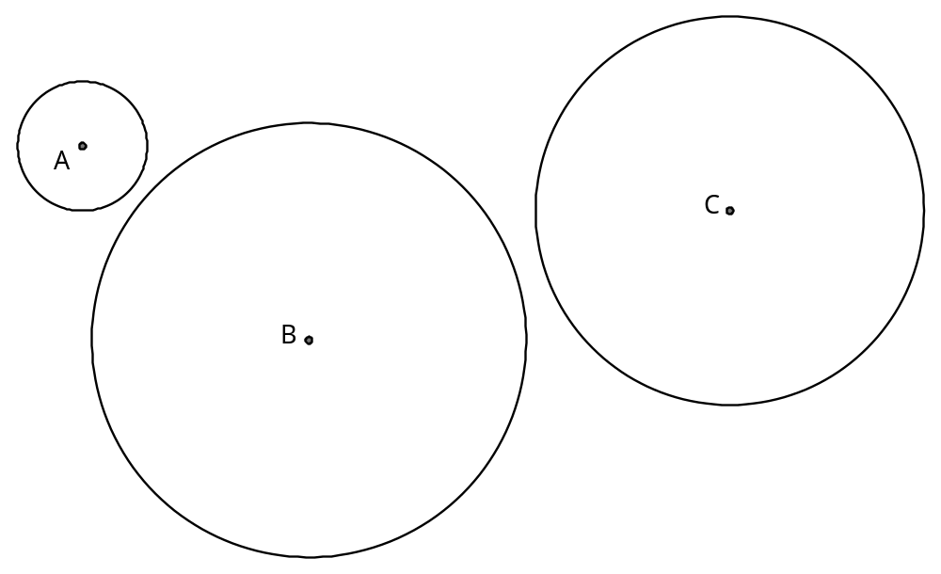
Complete the table below

circle | diameter | circumference
A
B
C

[6]
b) Approximately how many times will the diameter go around the circumference of a circle.

[2]

c) Give the approximate circumference of a circle that has a diameter of 200 m.

[2]

Question 18A [20 marks - C]
a) (i) Pick out the pairs of similar triangles and give the reason for similarity in each case.

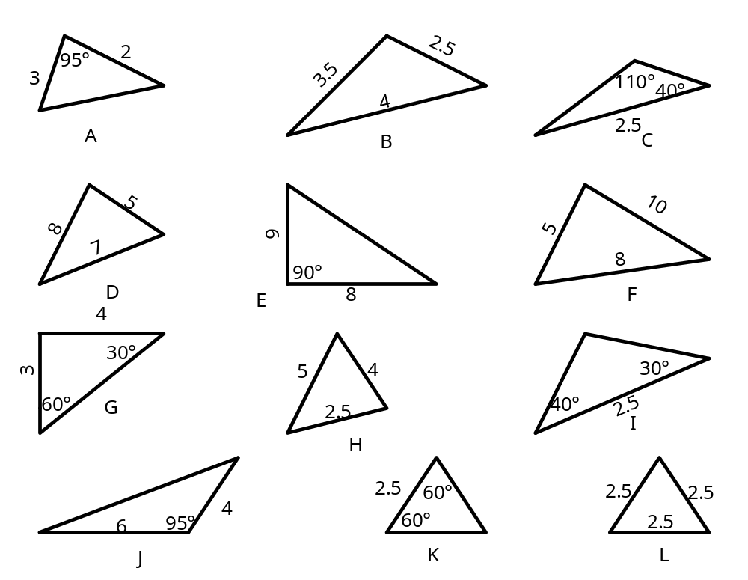

(ii) Which of the pairs of similar triangles are also congruent?
What condition for congruent triangle did you use to make this judgement?

[12]
b) Δ LQP ~ Δ LMN. Find LM and MN.
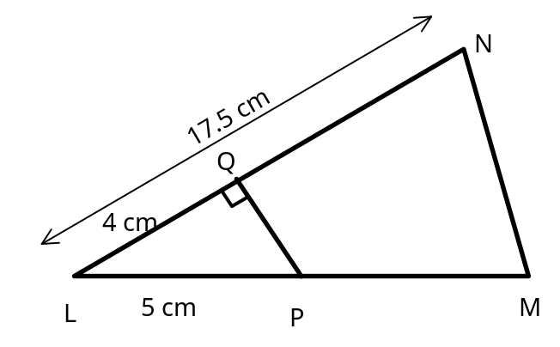

[4]

c) A mobile tower 24 metres high has two parallel wires that join from the mast to the ground. The first, from the top if the mast, is 26 m long and is fastened on the ground 10 metres from the foot of the mast. The second is fastened on the ground 7.5 m from the foot of the mast. Find the length of the second wire and how far up the mast it is fastened.
[4]
Question 18B [10 marks - C]

a) (i) Which of the following triangles are similar? Why?
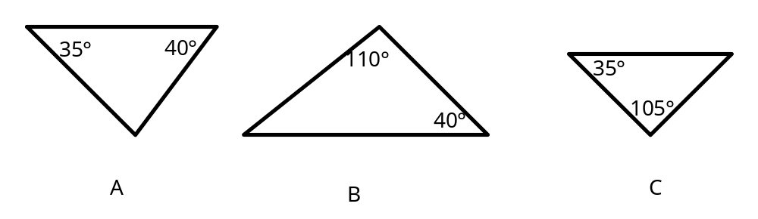

(ii) List the other conditions for similar triangles.

[4]

b) i) Δ LMN ~ Δ XYZ. Find XZ. Measurements are in centimetres.

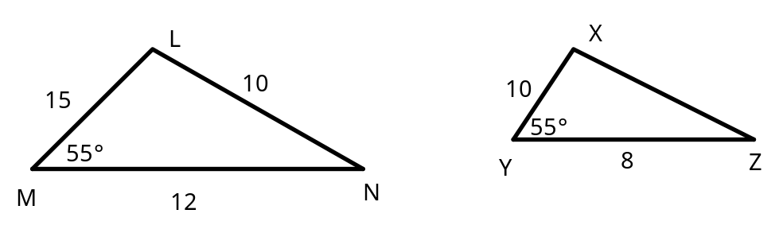

[3]

(ii) Δ ADE ~ Δ ABC. Find DB.
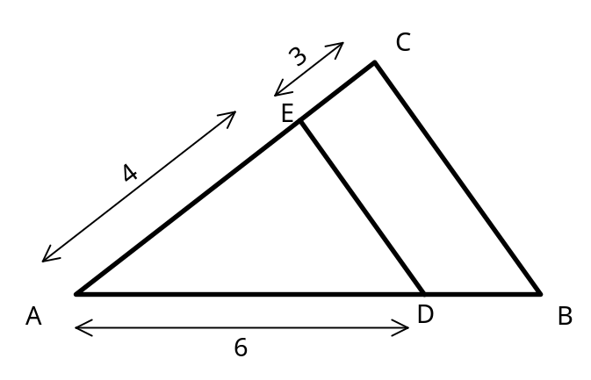
[3]
Question 18C [10 marks - C or NC]

a) Use the grid to enlarge the drawing.
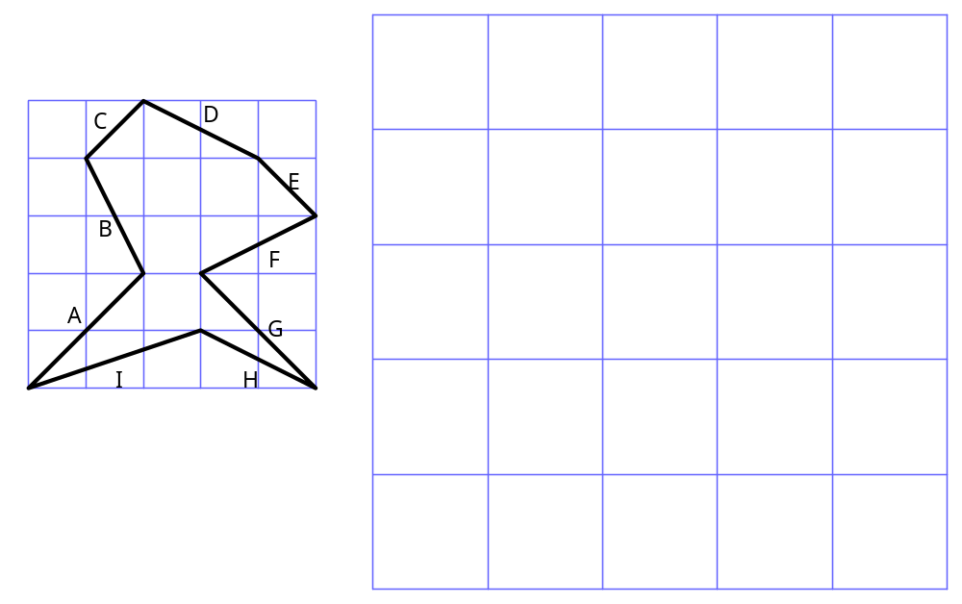
[3]

b) (i) Measure the length of the line labelled C in the first diagram to the nearest millimetre.

(ii) Measure the length of the line that you drew that corresponds to C to the nearest millimetre.

(iii) By what scale factor has the original shape been enlarged?

[5]
c) Similar figures have the same shape but not necessarily the same size. All shapes produced by an enlargement are similar to their original shape.
State true or false for the following

(i) all squares are similar _______
(ii) all rectangles are similar _______
(iii) all triangles are similar _______
(iv) all circles are similar _______
(v) all equilateral triangles are similar _______
[2]
Question 19A [10 marks - NC or C]

a) Each of the following figures contains a pair of congruent triangles. For each pair,
(i) state the congruence (ie Δ??? Δ???)
(ii) state the condition for congruent triangles that applies
(iii) describe a transformation which maps one triangle onto the other.

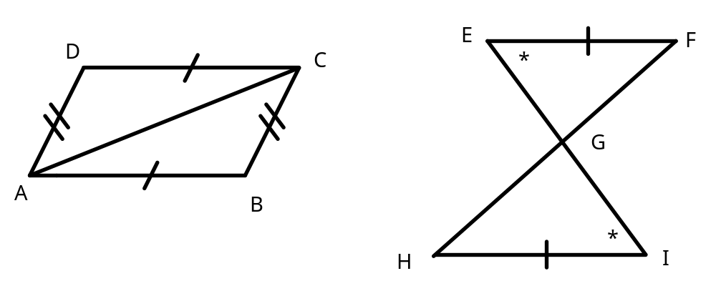

[10]

Question 20A [10 marks - C]

a) The longer of two supporting wires for a radio mast is inclined at 22º to the horizontal and is 4 m from the shorter wire. The shorter wire is 11m long.

(i) Find the angle between the two wires.
4 m
22º
11 m

(ii) Determine the length of the longer wire.

(iii) Find the height of the tower.

b) Two skiers leave the ski lift at noon and set off down the mountain. One heads for a tree (silly idea) 15m off to the right, whilst the other heads to the left at 2m/s. It takes the first skier 12 seconds to reach the tree. Her friend is now 18m away from her. At what angle did they first separate?

Question 20B [15 marks]

a) Use your calculator to evaluate the following to 4 decimal places.

(i) sin 55° (ii) tan 20°

[2]
b) Consider the following right triangle.
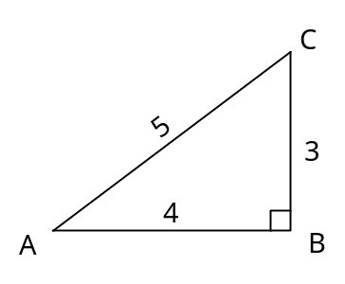 | (i) State the ratio for  cos A  sin A  tan A  (ii) Calculate the size of angle A.

[5]

c) (i) At a point 40 metres from the foot of a monument the angle of elevation of the top of the monument is 70°. How high is the monument?

[4]

(ii) A ladder 12 metre long just reaches the top of a building. The ladder is placed on level ground and makes an angle of elevation of 62° to the top of the building. Find how far the bottom of the ladder is from the building.

[4]

Question 20C [10 marks - NC]

a) (i) Make an accurate drawing of the following triangle.

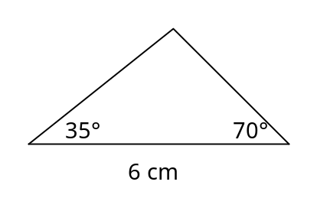

[3]
(ii) Classify the triangle. Choose words from the following: scalene, isosceles, right, obtuse, acute, equilateral.
[2]

b) (i) Make an accurate drawing of a parallelogram that has sides of 5 cm and 3 cm.

[3]
(ii) Is it possible to draw another parallelogram with the same measurement that will look different from the one you just drew? Explain.

